SVALBARD
Spitsbergen and the Ice Edge
10 – 17 June 2025
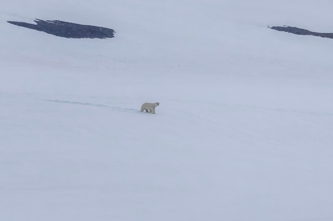
Polar Bear, Mushamna
Trip Report

Introduction
Our week amid the fjords and pack ice of northern Svalbard delivered the very best of high Arctic wildlife. From the seabird cliffs of Alkhornet, where Brünnich's Guillemot and Kittiwake numbered in their tens of thousands, to the drifting ice of the Greenland Sea, where two separate Polar Bear were found hauled out on the floes, this was a trip that showcased the archipelago at its most dramatic.
Walrus were seen at several sites, from a single animal at Mushamna to a haul-out of one hundred on the low-lying sands of Moffen Island, while Svalbard's more retiring mammals also showed well, with Arctic Fox at both Poolepynten and Alkhornet and good numbers of Svalbard Reindeer throughout. Bearded Seal, Harbour Seal and Harp Seal were all logged, and three species of cetacean — Beluga, Common Minke Whale and, best of all, Sperm Whale — were found during our time at sea.
The birding was equally rewarding, with King Eider and Long-tailed Duck among the wildfowl, a pair of Rock Ptarmigan in Liefdefjorden, and a fine spread of skuas and jaegers including Long-tailed, Parasitic and Great Skua. A run of days working the ice edge in the Greenland Sea produced the supporting cast that makes this such a special voyage: Sabine's Gull, Ivory Gull and Grey Phalarope among the birds, with Fin Whale, Humpback Whale, White-beaked Dolphin and Hooded Seal among the highlights offshore.
With calm seas for much of the week and excellent light long into the Arctic evening, we were able to make the most of every location, and the following diary records our progress around the archipelago.

Diary

Tuesday 10 June
We began in Longyearbyen, Svalbard's main settlement and gateway to the archipelago, where Barnacle Geese were already moving overhead in good numbers.
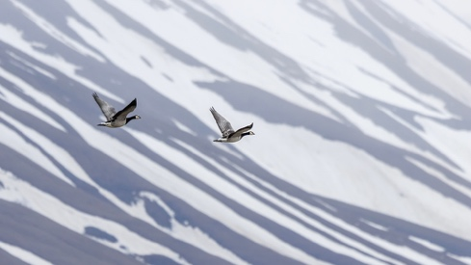
Barnacle Goose
The bay held excellent numbers of Common Eider, with one raft conservatively put at 250 birds, while Purple Sandpiper worked the shoreline rocks and a pair of Arctic Skua patrolled low over the tundra.
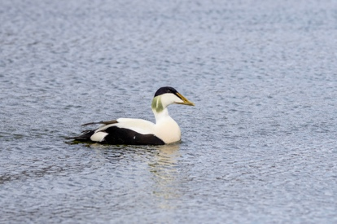
Common Eider
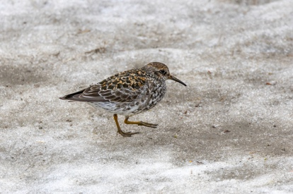
Purple Sandpiper
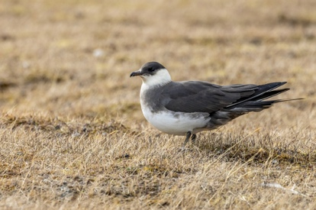
Arctic Skua
Black Guillemot and Little Auk were both already in evidence close to town, an early taste of the seabird spectacle to come, with Arctic Tern and Kittiwake also on show and a smart Glaucous Gull drifting overhead.
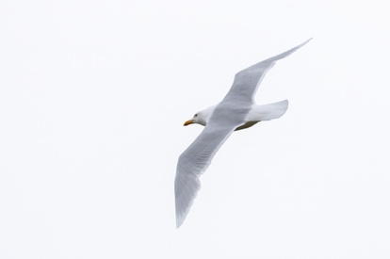
Glaucous Gull
A handsome adult Red-throated Diver sat close in on the water, Snow Bunting fed among the rocks, and a single Svalbard Reindeer grazed unconcerned nearby, with Purple Saxifrage already in flower — the first of many splashes of Arctic colour we would enjoy over the coming week.
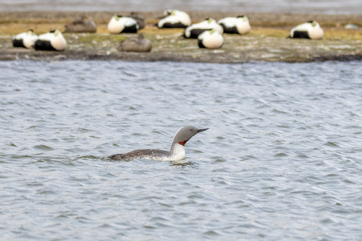
Red-throated Diver
Once underway, we made good progress into Isfjorden, where the cliffs produced our first proper seabird numbers of the trip, with Puffin, a healthy count of Brünnich's Guillemot and Fulmar, and further Kittiwake logged as we sailed north.
Overnight in Longyearbyen

Wednesday 11 June
A full day of exploration along Svalbard's north-west coast began at Lågøya, where Black Guillemot, Little Auk and Brünnich's Guillemot were all found among the usual supporting cast of Kittiwake, Glaucous Gull and Fulmar.
In Smeerenburgfjorden, Arctic Skua were much in evidence, harrying the local Kittiwakes and Black Guillemots, and Brünnich's Guillemot gathered in reasonable numbers close to the cliffs.
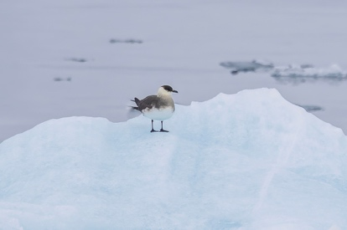
Arctic Skua
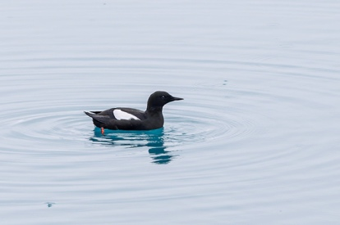
Black Guillemot
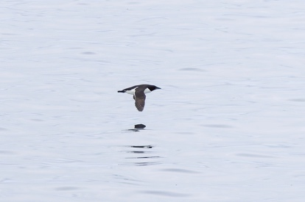
Brünnich's Guillemot
The undoubted highlight here, however, was a pod of three Beluga moving through the fjord, closely followed by a Harp Seal hauled out on the shoreline.
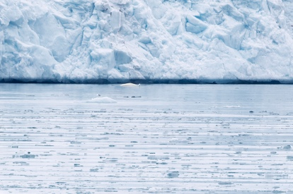
Beluga
At Ytre Norskøya, Barnacle Goose and Pink-footed Goose were added to the trip list, and a group of Great Skua patrolled the cliffs above a thriving colony that held Puffin, Black Guillemot and an impressive 500 Little Auk.
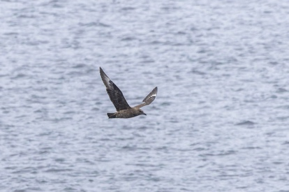
Great Skua
Arctic Tern were numerous overhead, with Kittiwake and Glaucous Gull both showing well, and closer to the ground we found Snow Bunting, Tufted Saxifrage and Purple Saxifrage among the tundra vegetation.
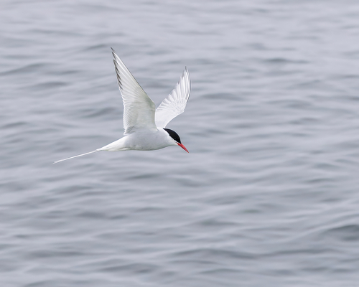
Arctic Tern
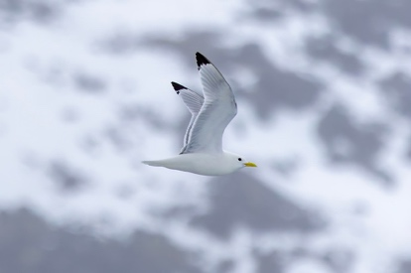
Kittiwake
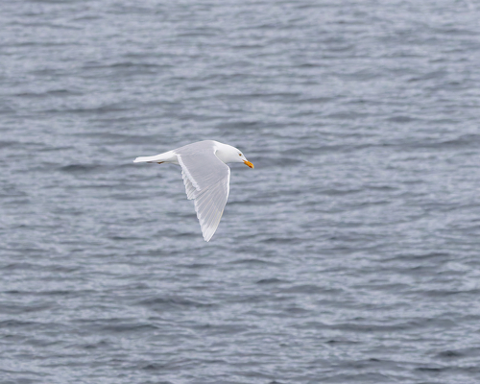
Glaucous Gull
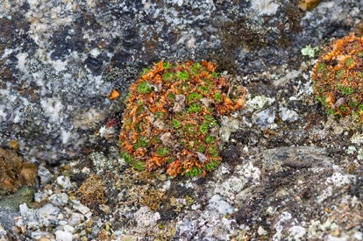
Tufted Saxifrage
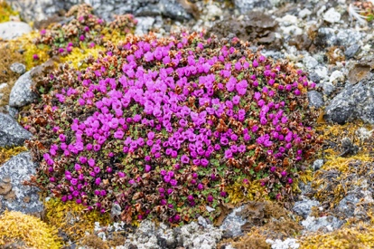
Purple Saxifrage
The day finished at Bruceneset in Raudfjorden, where a bustling colony delivered our best numbers yet, with 510 Little Auk, 300 Brünnich's Guillemot and a dozen Puffin all logged beneath a watchful Arctic Skua.
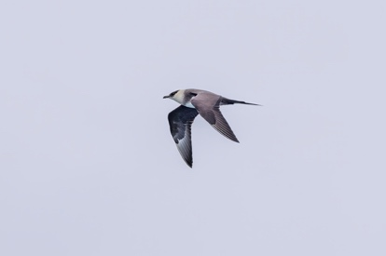
Arctic Skua
Overnight at sea

Thursday 12 June
Mushamna produced the first big mammal moment of the trip, with a Polar Bear forcing us to be evacuated from the island, closely followed by a single Walrus and a Svalbard Reindeer grazing on the tundra beyond.
Polar Bear
Common Eider, Purple Sandpiper and a pair of Arctic Skua were all recorded here too, along with Black Guillemot, Brünnich's Guillemot, Arctic Tern and Kittiwake, while both Red-throated Diver and Great Northern Diver sat out on the water and Fulmar passed offshore.
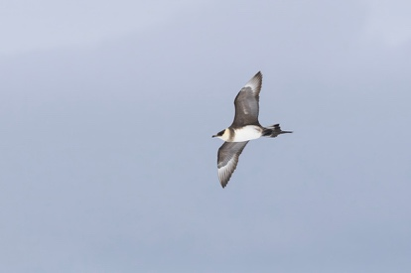
Arctic Skua
Liefdefjorden proved even richer, with a fine male Long-tailed Duck and a group of six King Eider among the wildfowl highlights, and two splendid male Rock Ptarmigan showing well on the slopes above the fjord.
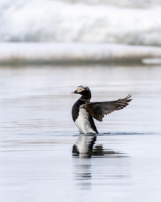
Long-tailed Duck
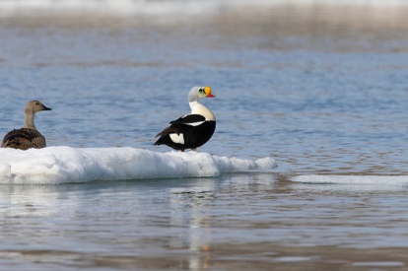
King Eider
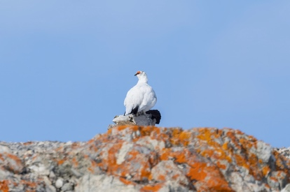
Rock Ptarmigan
Brünnich's Guillemot and Little Auk were both present in good numbers, with a single Common Guillemot among them, and Arctic Tern, Kittiwake, Glaucous Gull and Fulmar completed the seabird supporting cast.
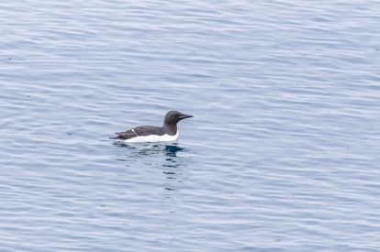
Brünnich's Guillemot
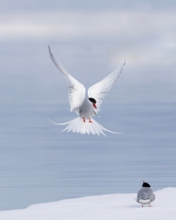
Arctic Tern
A pair of Bearded Seal was found hauled out on the ice, and the day's mammal list was rounded off in style by a Common Minke Whale surfacing nearby.

Bearded Seal
We finished the day at Moffen Island, where a small flock of Brent Goose and four Sabine's Gull were among the highlights, alongside Common Eider, Arctic Skua, Arctic Tern and Glaucous Gull, and where the island's famous Walrus haul-out did not disappoint, with counts building to around one hundred animals hauled out on the sand.
Overnight at sea

Friday 13 June
With a day given over to working the Greenland Sea, our attention turned firmly to pelagic species, and a flock of eight Brent Goose and a lone Dunlin were an unexpected start to proceedings.
Arctic Skua and Long-tailed Skua were both recorded, with the latter showing nicely as it patrolled low over the swell, while Black Guillemot, Little Auk and Brünnich's Guillemot continued to accompany the ship in varying numbers through the day.
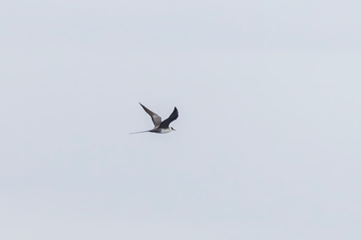
Long-tailed Skua
Arctic Tern, Kittiwake, Glaucous Gull and good numbers of Fulmar rounded out a satisfying seabird tally, and a pair of Ringed Seal was spotted resting on drifting ice.
The undoubted highlight of the day, however, came in the form of a Sperm Whale, a memorable and unexpected encounter this far north and a fitting reward for a day spent scanning the open sea.
Overnight at sea

Saturday 14 June
A second day at sea in the Greenland Sea began with Long-tailed Duck, Long-tailed Skua and Pomarine Skua all logged among the regular passage of Black Guillemot, Little Auk and Brünnich's Guillemot.
Arctic Tern, Kittiwake and a good spread of Glaucous Gull, including both adult and immature birds, continued the seabird theme, with Fulmar again well represented.
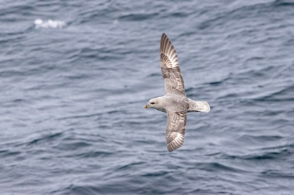
Fulmar
A Wheatear, clearly finding its own way south after the breeding season, was an unexpected sighting so far from land, but the day's star turn was a second Polar Bear of the trip, found hunting out on the pack ice and giving excellent views.
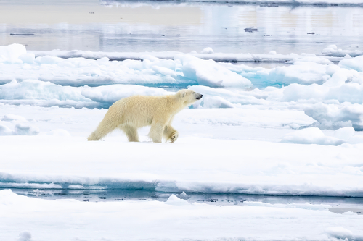
Polar Bear
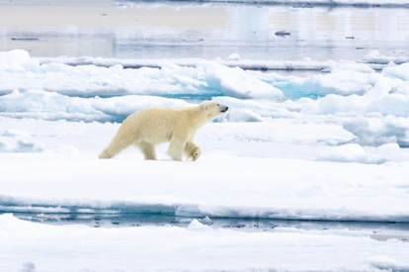
Polar Bear
A Harp Seal completed a rewarding day among the ice.
Overnight at sea

Sunday 15 June
Our third and most productive day in the Greenland Sea opened with Grey Phalarope, Arctic Skua and Long-tailed Skua all on show, the latter showing especially well as it worked the wake close to the ship.
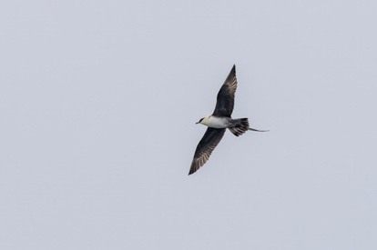
Long-tailed Skua
Puffin appeared in good numbers through the morning, and Black Guillemot, Little Auk and Brünnich's Guillemot remained ever-present.
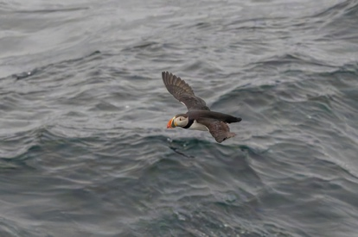
Puffin
Arctic Tern, Kittiwake and Glaucous Gull continued the supporting cast, and the day produced two genuine scarcities in the form of a Sabine's Gull and, better still, a pair of Ivory Gull, both smart Arctic specialities that had eluded us so far.
Fulmar were again numerous, and the marine mammal list grew steadily as the day progressed, with a Hooded Seal and impressive numbers of Harp Seal, several groups of Fin Whale, a Humpback Whale and a White-beaked Dolphin all logged from the deck.
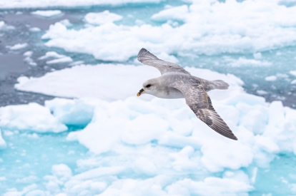
Fulmar
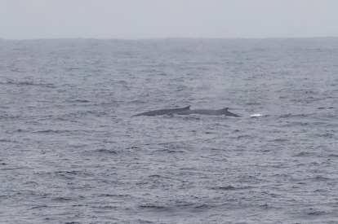
Fin Whale
It was undoubtedly the richest day of the voyage for cetaceans, and a fine reward for the hours spent scanning the open water.
Overnight at sea

Monday 16 June
A return to land brought us to Poolepynten, where Barnacle Goose, Ringed Plover, Grey Phalarope and Turnstone were found along the shoreline, with a Great Skua patrolling overhead and Arctic Tern, Kittiwake, Glaucous Gull and Fulmar all recorded.
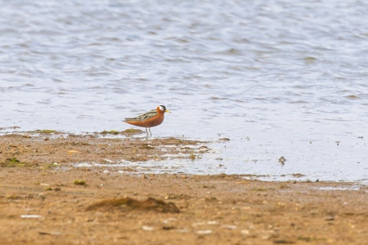
Grey Phalarope
An Arctic Fox was a popular sighting as it trotted along the beach, and a fine haul-out of thirty Walrus provided plenty of entertainment, while eight Svalbard Reindeer grazed nearby and Tufted Saxifrage flowered among the rocks.
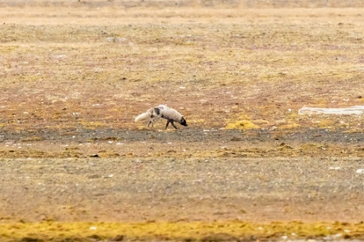
Arctic Fox
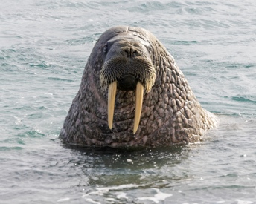
Walrus
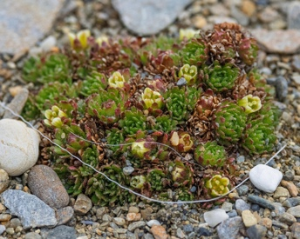
Tufted Saxifrage
Alkhornet delivered the seabird spectacle of the trip, with quite remarkable numbers of Brünnich's Guillemot and Kittiwake packed onto the cliffs — counts here ran into the tens of thousands of each species, one of the great sights of the Arctic summer.
Pink-footed Goose, Common Eider, Purple Sandpiper, Arctic Skua and a second Great Skua of the day were all logged, along with Glaucous Gull, Fulmar and Snow Bunting.
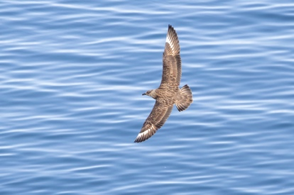
Great Skua
A second Arctic Fox was found here too, along with a Harbour Seal resting on the shore, two further Svalbard Reindeer and a fine stand of Arctic Mouse-ear in flower, a fitting finale to a day rich in both birds and mammals.
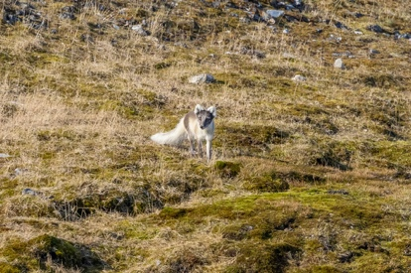
Arctic Fox
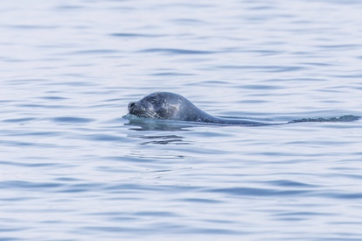
Harbour Seal
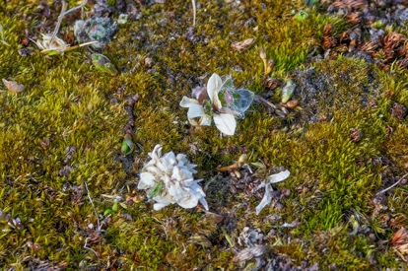
Arctic Mouse-ear
Overnight at sea

Tuesday 17 June
Our final morning was spent back around Longyearbyen, where an impressive 327 Barnacle Geese were logged, our largest count of the trip, alongside Long-tailed Duck, King Eider and Common Eider in numbers building to 300 birds on the water.
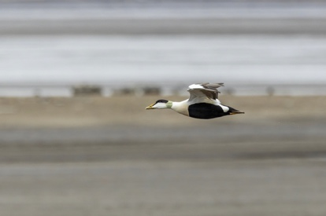
Common Eider
Ringed Plover, Dunlin and Purple Sandpiper worked the shoreline, with Black Guillemot, Arctic Tern and Glaucous Gull also recorded, and a final Red-throated Diver and a smart Snow Bunting brought a memorable week of Svalbard birding and wildlife to a satisfying close.
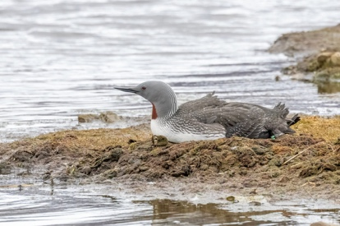
Red-throated Diver
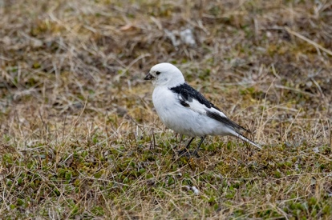
Snow Bunting
It had been an outstanding week in the high Arctic, with Polar Bear seen on two occasions, superb numbers of breeding seabirds, a fine spread of Arctic wildfowl and waders, and a marine mammal list that few voyages in the region can match.

